These graphs show the perceptual positions of the SKUs by category and market. The positions are color-coded by supplier and retailer (for private label SKUs). Moving the cursor on any of the circles will identify the SKU and the exact perceptual coordinates of that SKU.

Performance Highlights

Market Shares

Sales

Segment Leadership

Cross-Segment Sales Volumes

Product Portfolio

eMall Prices and Promotion Intensity

Financial Results

Elecssories Situation Reports

HealthBeauties Situation Reports

Key Performance Indicators

Awareness

**Brand Perceptions**

Elecssories – Urban

Elecssories – Rural

**HealthBeauties – Urban**

HealthBeauties – Rural

Retailer Perceptions

Market Shares by Consumer Segment

Sales by Consumer Segment

Market Shares by Shopper Segment

Sales by Shopper Segment

Sales by Channel

B&M Retail Prices

Promotion Intensity

Supplier Intelligence

Retailer Intelligence

Forecasts

Brand Perceptions – HealthBeauties Urban

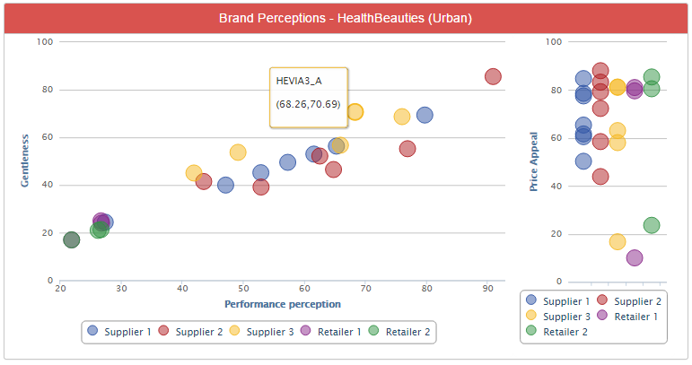

**HEVIA3_A**

Performance: 59 (10%)

Gentleness: 39 (- 9%)

Attractiveness for

Price Sensitive: 93

Value for Money: 10

Health Conscious: 5

Impatient: 0

s